* Copyright for test papers and marking guides remains with *West Australian Test Papers*.
* The papers may only be reproduced within the purchasing school according to the advertised conditions of sale.
* Test papers must be withdrawn after use and stored securely in the school until October 13th.

**HUMAN BIOLOGY**

**Units 3 & 4**

**2022**

**SOLUTIONS**



Name: _______________________________________________________

Teacher: ___________________________________________________

**Time allowed for this paper**

Reading time before commencing work: ten minutes

Working time: three hours

**Materials required/recommended for this paper**

***To be provided by the supervisor***

This Question/Answer booklet

Multiple-choice answer sheet

***To be provided by the candidate***

Standard items: pens (blue/black preferred), pencils (including coloured), sharpener, correction fluid/tape, eraser, ruler, highlighters

Special items: up to three calculators, which do not have the capacity to create or store programmes or text, are permitted in this ATAR course examination

**Important note to candidates**

No other items may be taken into the examination room. It is **your** responsibility to ensure that you do not have any unauthorised material. If you have any unauthorised material with you, hand it to the supervisor **before** reading any further.

**Section One: Multiple Choice 30% (30 Marks)**

|  |  |
| --- | --- |
| Question | Solution |
| 1 | C |
| 2 | D |
| 3 | A |
| 4 | D |
| 5 | A |
| 6 | C |
| 7 | A |
| 8 | D |
| 9 | D |
| 10 | C |
| 11 | B |
| 12 | A |
| 13 | C |
| 14 | A |
| 15 | C |
| 16 | B |
| 17 | D |
| 18 | D |
| 19 | C |
| 20 | D |
| 21 | D |
| 22 | B |
| 23 | B |
| 24 | A |
| 25 | A |
| 26 | B |
| 27 | D |
| 28 | A |
| 29 | C |
| 30 | B |

**End of Section One**

**Section Two: Short answer 50% (100 Marks)**

This section has **seven** questions. Answer **all** questions. Write your answers in the spaces provided.

Supplementary pages for planning/continuing your answers to questions are provided at the end of this Question/Answer booklet. If you use these pages to continue an answer, indicate at the original answer where the answer is continued, i.e. give the page number.

Suggested working time: 90 minutes.

**Question 31 (20 marks)**

(a) Complete the table below for each of the following scenarios by placing the letter (A, B, or C) in the correct box to show the type of immunity it demonstrates. (3 marks)

A Catching tetanus from a rusty nail

B A one month old does not suffer from the cold her mother has

C Being given an injection after being bitten by a snake

|  |  |  |
| --- | --- | --- |
| **Type of Immunity** | **Natural Immunity** | **Artificial Immunity** |
| **Active Immunity** | A (1) |  |
| **Passive Immunity** | B (1) | C (1) |

(b) Genes isolated from DNA can be used in gene therapy to treat conditions like cystic fibrosis. Healthy individuals have a gene that codes for a channel protein found in the cell membrane of many body cells, including those lining the trachea. People suffering from cystic fibrosis do not have a functioning gene, so their cells do not form these channel proteins.

(i) The treatment of cystic fibrosis is described as a somatic gene therapy. Another type of gene therapy is known as a germ-line therapy. State **two** differences between somatic gene therapy and germ-line therapy. (4 marks)

|  |  |
| --- | --- |
| Somatic Gene Therapy | Germ-line Therapy |
| Occurs in body cells (1) | Occurs in reproductive organs (1) |
| Not inheritable (1) | Inheritable (1) |
| Will only treat this individual (1) | Will not treat this individual / will treat this individual’s offspring (1) |

(Any 2 points, matched, 1 mark each, max of 4 marks)

(ii) A student suggested his elderly grandmother, who suffers from Alzheimer’s, could be treated with gene therapy. His friend suggested she should be treated with cell replacement therapy. Explain who is correct. (3 marks)

The friend is correct (1)

Alzheimer’s is not due to a single gene mutation / no known genetic cause (1)

Cell replacement would allow appropriate levels of acetylcholine from cells that function correctly (1)

(c) Two children were given an injection. They were then tested each day to determine the levels of antibodies in their blood. Their results are shown below.

|  |  |  |
| --- | --- | --- |
| Time (days) | Levels of antibodies in the blood (kAU) | |
| Child 1 | Child 2 |
| 0 | 5 | 5 |
| 1 | 20 | 190 |
| 3 | 100 | 170 |
| 5 | 150 | 130 |
| 9 | 90 | 30 |
| 14 | 60 | 10 |
| 15 | 50 | 3 |

(i) Graph this data to show how the antibody level changed over time for each child. (5 marks)

Title: Change in antibody level in the blood for two children over time (1)

X axis named with units: Time (days) (1)

Y axis named with units: Levels of antibodies in the blood (kAU) (1)

Scales appropriate on both axes (1)

Line graph produced with data points connected by straight lines (1)

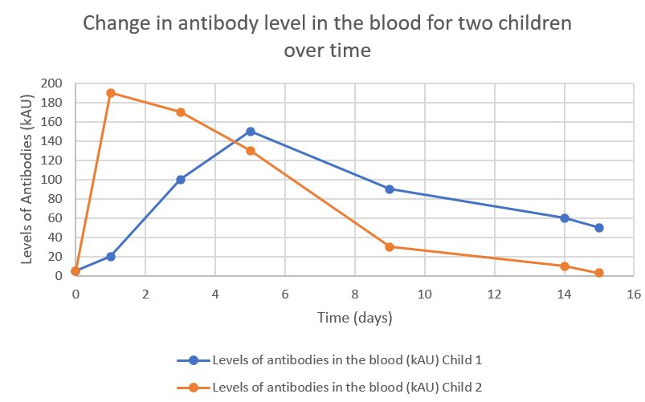

(ii) What was contained in the injection given to Child 2? (1 mark)

Antibodies (1)

(iii) Explain the immunological response of Child 1 if they came into contact with the same antigen that caused this response, in the future. (2 marks)

Response would be faster / stronger / larger (1)

As they would have had memory cells present from the first introduction to the antigen (1)

(iv) State **two** ways in which antibodies can act against an antigen. (2 marks)

Agglutination / lysis of antigens / coat bacteria and enhance phagocytosis / prevent viruses from entering cells / make soluble substances insoluble / inhibiting antigen’s reaction with other cells (Any 2, 1 mark each)

**Question 32 (16 marks)**

People who suffer from Type I and Type II diabetes are encouraged to consume food with a

low glycaemic index (GI). The glycaemic index rates food from 0 to 100, indicating how quickly

it increases blood glucose concentrations.

To determine the GI of a biscuit, scientists asked 5 people to fast overnight. The next morning,

each person consumed one biscuit and blood samples were taken every 15 minutes for 2

hours in order to determine their blood glucose concentration. The mean value of all subjects

was used to determine the GI for that food.

(a) Why were all subjects asked to fast overnight? (2 marks)

As a control (1)

In order to compare this data to their blood glucose level after eating the biscuit (1)

(b) For the GI calculation to be valid, a number of variables must be controlled. Suggest **two** variables that must have been controlled. (2 marks)

All subjects were healthy / did not have diabetes (1)

All subjects fasted for the same amount of time (1)

All subjects did not perform any activity / exercise (1)

(Any 2, 1 mark each)

(c) The mean value of all subjects was used to calculate the GI of the biscuit. Explain why the mean value for all subjects was used and suggest one limitation of this method.

(2 marks)

In order to show the average blood glucose level for all subjects (1)

Limitation – anomalies / outliers can increase / decrease the mean value (1)

(d) How could the determination of the GI of the biscuit be made more reliable?

(1 mark)

Use more subjects / replication / repeat the experiment / repetition (Any 1, 1 mark)

Older people can develop a condition called Type II diabetes, where they have high blood glucose levels, even though they produce normal amounts of insulin.

(e) Explain why these people have high blood glucose levels, even though they may produce normal amounts of insulin. (1 mark)

Cells not responsive to insulin / receptors desensitised to insulin (1)

(f) Suggest **two** symptoms a person would experience if they suffered from Type II diabetes. (2 marks)

Increased urination / fatigue / glucose in urine / thirst / (Any 2, 1 mark each)

(g) Suggest **two** changes a person suffering from Type II diabetes could make in order to better manage their blood glucose levels. (2 marks)

Increase exercise / decrease dietary intake of high GI food / lose weight

(Any 2, 1 mark each)

(h) Insulin targets the liver. What other main tissue type does insulin target? (1 mark)

Skeletal muscle (1)

(i) Name the process that occurs in the liver as a result of insulin being present. (1 mark)

Glycogenesis (1)

(j) State the effect of adrenalin on blood glucose levels and explain why this is required at times. (2 marks)

Increases blood glucose levels (1)

Provide glucose for skeletal muscles / increased cell respiration during flight, fight, fright situations (1)

**Question 33 (9 marks)**

The flowchart below shows the endocrine glands and hormones involved in altering the rate of metabolism in a healthy person.

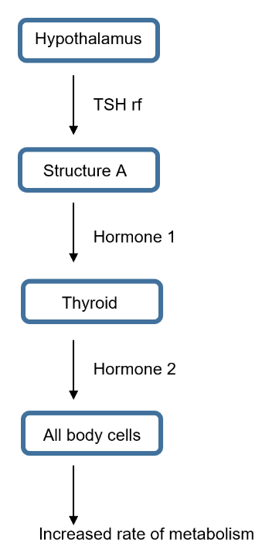

(a) Name Structure A and describe how TSHrf travels to it. (2 marks)

Anterior pituitary (1)

Through the bloodstream (1)

(b) Explain why Hormone 1 only affects the thyroid while Hormone 2 can affect all body cells. (2 marks)

Hormones are specific (1)

Only thyroid cells have the receptor for Hormone 1 while all body cells have the receptor for Hormone 2 (1)

(c) In order for Hormone 2 to be produced, it requires a substance in the diet. What is the name of this substance? (1 mark)

Iodine (1)

(d) Julie was not feeling well and had been losing weight, so she went to her doctor. He gave her a radioactive substance and scanned her thyroid before comparing her result to that of a healthy person. The results are shown below.

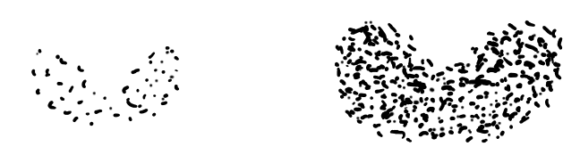

Healthy Person Julie

(i) What condition is Julie suffering from? (1 mark)

Hyperthyroidism (1)

(ii) Other than weight loss, name **two** symptoms Julie may be experiencing. (2 marks)

Goitre / bulging eyeballs / fatigue / heat intolerance / increased sweating / increased heart rate / increased blood pressure / hyperexcitability / abnormal brain function (Any 2, 1 mark each)

(iii) The doctor suggested an operation to remove part of her thyroid. Explain why this would be an appropriate treatment for Julie’s condition. (1 mark)

Remove part of the thyroid so not as much thyroxine will be released (1)

**Question 34 (16 marks)**

(a) Explain why the pH of blood can decrease. (3 marks)

Carbon dioxide is produced as a product of cell respiration (1)

Carbon dioxide combines in water to form carbonic acid (1)

Which dissociates to form bicarbonate ions and hydrogen ions (which reduces pH) (1)

(b) Low pH reduces the affinity for oxygen to bind to haemoglobin in people with sickle cell trait and they suffer a sickle crisis. State **two** symptoms of someone with a sickle crisis. (2 marks)

Pain in joints / breathlessness / weakness / thirst / pale lips / swelling of hands and feet / frequent infections / vision issues / delayed growth (Any 2, 1 mark each)

(c) Sickle cell anaemia is the result of a mutation and can be passed on to offspring.

(i) What is a mutation? (1 mark)

Any change in the DNA (1)

(ii) Explain whether the sickle cell mutation is a gene or chromosomal mutation. (1 mark)

Gene mutation (1)

As there is only one effect / doesn’t affect a number of structures (1)

(d) A gel electrophoresis was conducted for three members of a family.

(i) Describe the role of the electrical current in gel electrophoresis. (2 marks)

Force the DNA across the gel / away from the well (1)

So it can be separated by size (1)

Gel electrophoresis was carried out for the family to determine whether or not any of

them had the sickle cell allele. Their results are shown below.

**Negative Positive**

Mum

Child 1

Child 2

Dad

(ii) Given Child 2 has sickle cell anaemia, complete Dad’s lane in the image above. (1 mark)

Both bands present as shown in the image above / same bands as Child 2 (1)

(e) Discuss how and provide reasons why the frequency of the sickle cell allele would vary in North America and in Africa. (5 marks)

North America

Sickle cell frequency will be lower (1)

As malaria is not present / no selection pressure from malaria (1)

Africa

Sickle cell frequency will be higher (1)

as malaria is present (1)

and a heterozygote advantage for malaria exists (1)

**Question 35 (17 marks)**

Recently, a mining giant funded an archaeological excavation at the Yirra rock shelter near Paraburdoo in the Pilbara of Western Australia, where they retrieved stone tools, charcoal and bone. Six individuals were identified, 4 adults and 2 children. The fossils were dated at 50,000 years. Mitochondrial DNA testing determined that three of the adults and both children were related to each other.

(a) Explain how these specimens could have been dated. (5 marks)

Carbon 14 dating (1)

From sample of bone / charcoal (1)

Amount of C14 is fixed at death (1)

And decays at a fixed rate / has a half life of 5730 years (1)

Ratio of C14 : C12 decreases over time and determines the age of specimen (1)

(b) Mitochondrial DNA was used to determine the relatedness of the individuals found in the rock shelter. Explain one advantage and one disadvantage of using mitochondrial DNA rather than nuclear DNA. (3 marks)

Advantages: (Any 1, explained, 2 marks)

Lots of mitochondria present in cells (1)

Which means there is a large amount of DNA for testing (1)

OR

Has a higher mutation rate than nuclear DNA (1)

So relationships can be seen more easily (1)

Disadvantage: (Any 1, explained, 1 mark)

Makes it difficult to determine how some males are related in a mixed group / doesn’t indicate the father of children (1)

(c) At another site in Europe, scientists determined their specimens belonged to *Homo neanderthalensis*. State **one** anatomical and **two** cultural differences that existed between *Homo neanderthalensis* and *Homo sapiens* (Cro Magnon). (6 marks)

|  |  |  |
| --- | --- | --- |
|  | ***Homo neanderthalensis*** | ***Homo sapiens* (Cro Magnon)** |
| **Anatomical** | Short and stocky / occipital bun / average cranial capacity 1520cc / large lower jaw and teeth / no chin / weak forehead / thick boned cranium / skull not dolicocephalic  (Any 1, 1 mark) | Taller and thinner / no occipital bun / average cranial capacity 1330cc / more delicate lower jaw and teeth / chin present / strong forehead / hin boned cranium / dolicocephalic skull shape  (Any 1, 1 mark) |
| **Cultural** | Mousterian tool culture / buried their dead / performed rituals (eg: bear clan)  (Any 2, 1 mark each) | Aurignacian / Solutrean / Magdalanian tool culture / developed mural and portable art / modern language / performed religious rituals  (Any 2, 1 mark each) |

(d) Two tools, excavated from different archaeological sites, were compared. Tool A was found attached to a portion of a stick while Tool B was not. (These images are not to scale).

Tool A Tool B

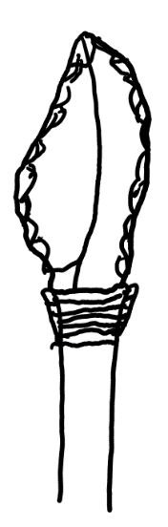 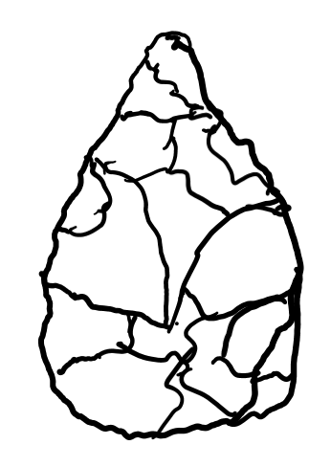

(i) What is the method of attaching tools to wood called? (1 mark)

Hafting (1)

(ii) Which hominin would have produced Tool B? (1 mark)

Homo erectus (1)

(iii) Which tool, Tool A or Tool B, would have been produced first? (1 mark)

Tool B (1)

**Question 36 (16 marks)**

(a) Describe one way that each, the nervous and endocrine systems, can affect breathing rate and explain why being able to use both these systems is an advantage. (6 marks)

Nervous

Through Autonomic / sympathetic / parasympathetic / voluntary motor control (Any 1, 1 mark)

Causes it to increase / decrease breathing rate / be able to hold breath (1)

Endocrine

Through Adrenalin (1) - Increases breathing rate (1)

Advantage –

Endocrine effects will last longer (1)

Nervous acts quickly (1)

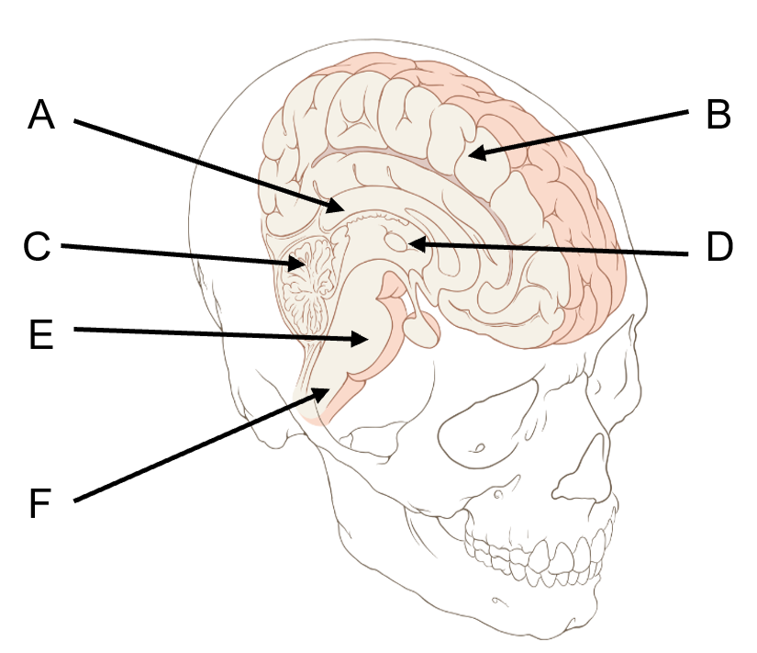

G

(b) Name structure A. (1 mark)

Corpus callosum (1)

(c) Explain how damage to structure G could result in less cortisol being produced. (2 marks)

Damage to the anterior pituitary would produce less ACTH (1)

Which would no longer stimulate the adrenal cortex to release cortisol (1)

(d) Which structure/s shown on the image above would be involved in playing the violin? (2 marks)

B (1) and C (1)

(e) Which structure/s shown on the image on the previous page would be involved in smelling dinner cooking and remembering what it was? (1 mark)

B (1)

(f) Describe how the spinal cord is protected from injury. (2 marks)

Bony vertebral column surrounds the spinal cord to protect from knocks / blows (1)

Meninges surround the spinal cord and cushion the spinal cord (1)

Cerebrospinal fluid acts as a shock absorber (1) (Any 2, 1 mark each)

**Question 37 (8 marks)**

The graph below represents the voltage across the membrane of an axon and the changes that take place during the generation and transmission of an action potential.

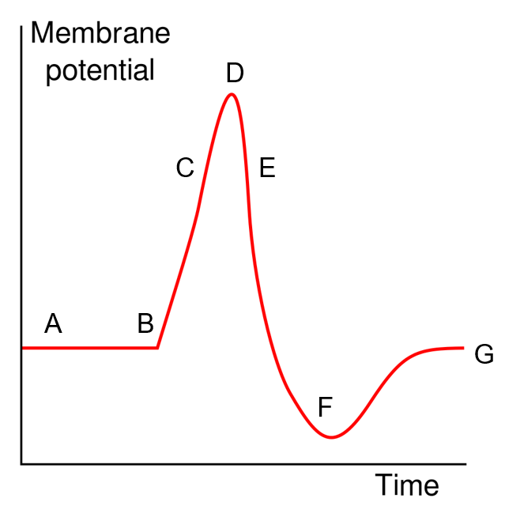

(a) Use the letters A to G to state when each of the following events are occurring. A letter may be used once, more than once or not at all. (4 marks)

|  |  |
| --- | --- |
| **Event** | **Letter/s** |
| Voltage gated potassium channels are open | E (1) |
| Depolarisation | C (1) |
| Potassium ions are actively moved into the neuron | Either A or G,  and F (1) |
| Sodium potassium pumps are operating | Either A or G,  and F (1) |

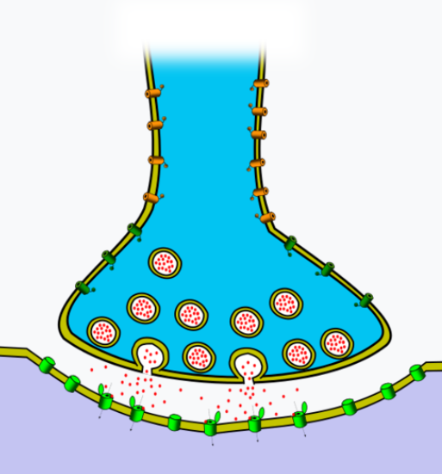

(b) The image above shows the mechanism by which an action potential crosses a synapse. Describe how this process and the release of oxytocin are similar. (4 marks)

Oxytocin and neurotransmitters are both held in vesicles (1)

Nerve impulse / action potential causes their release (1)

Vesicles move to the surface due to the presence of calcium (1)

Release of chemicals is by the process of exocytosis (1)

Oxytocin and neurotransmitters diffuse across synapse / into intercellular fluid (1)

Both target receptors on other cells (1)

(Any 4, 1 mark each)

**End of Section Two**

**Section Three: Extended answer 20% (40 Marks)**

This section contains **four** questions. You must answer **two** questions.

Questions 38 and 39 are from Unit 3. Questions 40 and 41 are from Unit 4. Answer **one** question from Unit 3 and **one** question from Unit 4.

Responses could include clearly labelled diagrams with explanatory notes; lists of points with linking sentences; clearly labelled tables and graphs; and annotated flow diagrams with introductory notes.

Supplementary pages for planning/continuing your answers to questions are provided at the end of this Question/Answer booklet. If you use these pages to continue an answer, indicate at the original answer where the answer is continued, i.e. give the page number.

Suggested working time: 50 minutes

_________________________________________________________________________

**Unit 3**

Choose **either** Question 38 **or** Question 39.

Indicate the question you will answer by ticking the box next to the question. Write your answer on pages 27-31. When you have answered your first question, turn to page 32 and indicate on that page the second question you will answer.

**Question 38 (20 marks)**

Vaccines were first developed by Edward Jenner in 1796 when he observed that milk maids who milked cows suffered from a mild cowpox but did not suffer from the severe smallpox disease. In order to protect a young boy from the dangerous smallpox disease, Jenner scratched the boy’s skin with the mild cowpox disease.

(a) Compare and contrast the different types of vaccines that use whole organisms and give an example of each type. (8 marks)

|  |  |
| --- | --- |
| Attentuated living (1) | Dead/ inactivated microorganisms (1) |
| Eg: polio / tuberculosis / rubella / mumps  / measles (1) - compulsory | Eg: Cholera / typhoid / whooping cough (1) - complusory |
| Attenuated Last longer where as dead Do not last as long (1) | |
| Attenuated provide a stronger immune response / memory where as dead provide a weaker immune response / memory (1) | |
| Weakened by heat / chemicals / ultraviolet light (1)  Produce memory cells (1)  Given before catching the disease (1)  Artificial (1)  Active (1)  Can be injected (1)  (Any 2, 1 mark each) | |

(b) The formation of subunit vaccines requires the use of recombinant DNA technology. Describe in detail how a subunit vaccine could be produced and briefly explain why it is not possible for people receiving a subunit vaccine to actually suffer from the disease due to the vaccination itself. (12 marks)

Subunit is a part of a virus or bacteria that can cause an immune response (1)

Protein/subunit specific to that antigen/pathogen must be identified (1)

Gene that produces that protein must be identified (1)

Gene is cut out of the donor DNA/ pathogen by restriction enzymes (1)

Plasmids are retrieved from bacteria source (1)

The same restriction enzyme is used to cut open the plasmids (1)

DNA ligase is used to join the protein gene combination into the plasmids (1)

Plasmids are introduced back into bacteria (1)

This is now called a vector (1)

Recombinant bacteria are provided appropriate conditions to grow (1)

They produce the protein specific to the antigen/ pathogen which is harvested (1)

Proteins are harvested, purified and packaged. (1)

These proteins are given as subunit vaccines (1)

(Any 11 marks, 1 mark each)

It is not possible to actually suffer from the disease as only the protein is contained in the vaccine, not the whole organism (1, compulsory mark)

**Question 39 (20 marks)**

John was in need of a kidney transplant. Doctors tested his family members for the possibility of one of them being a living donor.

(a) Describe the immune response John would have to a new kidney if no immunosuppressants were provided. (10 marks)

(Any 6 points, 1 mark each)

B cells / macrophages encounter a non-self antigen (1)

engulf it, digest and process it and then present small fragments of it on their surface (1)

They then present it to T cells (1)

If the T cell recognises the antigen it becomes activated and sensitised (1)

increases in size and divides, producing clones (1)

Killer T cells migrate to the site of infection (1)

and act by attaching to the antigen and secreting chemicals that destroy it (1)

Helper T cells act by secreting chemicals / cytokines (1)

(Any 2 points, 1 mark each)

that attract lymphocytes / macrophages to the area (1)

sensitise these lymphocytes to act like these T cells (1)

intensify the process of phagocytosis (1)

promote the action of killer T cells (1)

(Any 2 points, 1 mark each)

Memory T cells remember the antigen for the future and initiate a very rapid response (1)

Suppressor T cells take part when the immune response is excessive or no longer required (1)

and act by secreting chemicals that inhibit T and B cell activity, slowing the immune response (1)

(b) The kidney is a target for both aldosterone and antidiuretic hormone. Differentiate between the modes of action of these two hormones. (10 marks)

(Any 5 points, matched, 1 mark each)

|  |  |
| --- | --- |
| **Aldosterone** | **Antidiuretic Hormone** |
| Soluble in lipids | Soluble in water |
| Active for a long time | Active for a shorter time |
| Travel in blood attached to a protein | Travel in blood dissolved in plasma |
| Enter cells | Do not enter cells |
| Receptors in cytoplasm / on organelles / in nucleus / on DNA | Receptors in / on cell membrane |
| Does not use a secondary messenger | Uses a secondary messenger |
| Alters gene functioning | Alters enzyme functioning |

**Unit 4**

Choose **either** Question 40 **or** Question 41.

Indicate the question you will answer by ticking the box next to the question. Write your answer on the pages provided.

**Question 40 (20 marks)**

(a) *Australopithecus robustus* and *Australopithecus africanus* were considered closely related to each other and derived from a common ancestor, *Australopithecus afarensis*. After careful analysis, *Australopithecus robustus* was reclassified as *Paranthropus robustus*.

Draw and label a phylogenetic tree to show the relationship between these

three species before analysis and describe the key anatomical aspects of the

robust form that might have resulted in the change in classification. (6 marks)

Before the analysis

(2 marks for the phylogenetic tree, 1 mark for correct organisation, 1 mark for labelling)

*Australopithecus Australopithecus*

*robustus africanus*

*Australopithecus*

*afarensis*

Anatomical aspects - Larger body size / larger molars and premolars / smaller average

relative cranial capacity / has a sagittal crest / heavy zygomatic arches (Any 4, 1 mark each)

(b) *Homo habilis* was the first hominin specimen considered to be fully upright and bipedal. Describe the characteristics of the structural adaptations that allowed this hominin to stand and move in this way. (14 marks)

(Any 14, 1 mark each)

|  |  |
| --- | --- |
| **Body region** | **Characteristics** |
| **Pelvis** | Short and broad |
|  | Acetabulum positioned more laterally |
|  | Bowl shaped |
| **Vertebral column** | Wedge shaped lumbar vertebrae |
|  | S shaped |
|  | Spinous processes in neck smaller |
|  | Spinous processes in lower back larger |
|  | Spinous processes in neck positioned more vertically |
| **Cranium** | Smaller lower jaw / reduced prognathism |
|  | Centrally placed foramen magnum |
|  | Smaller nuchal area |
| **Foot** | Longitudinal and transverse arch |
|  | Non opposable/ large big toe |
|  | Non prehensile/ parrallel toes |
|  | Large robust heel / calcaneus |
| **Femur/ Knee** | Greater Carrying angle/ femur angled towards midline |
|  | Comparatively Femur is longer and larger |
|  | Knee is more robust/buttress of lateral condyle |
|  |  |
|  | Legs are longer than arms |
|  |  |

**Question 41 (20 marks)**

(a) Population A, a large population with gene flow, began with an allele frequency of 50% H and 50% h. Population B, a small, isolated population, also began with an allele frequency of 50% H and 50% h. At the end, Population A had become 52% H and 48% h, while Population B has become 80% H and 20% h.

Explain what processes are occurring in each population that resulted in the final allele frequencies. (10 marks)

Population A - Natural Selection is occurring (1, compulsory mark)

(Any 5 marks, 1 mark each)

There is variation in their allele frequency (1)

More individuals are born than survive to maturity (1)

A species usually maintains its numbers over time (1)

Some features are adaptive - they aid survival (1)

Selective forces are in play / a struggle for existence occurs (1)

Selective forces kill off / reduce the fertility of less well adapted organisms (1)

The well adapted individuals survive and reproduce (1)

So this favourable feature is passed on to the next generation (1)

And therefore increases in frequency from one generation to the next (1)

Population B - Random genetic drift is occurring (1, compulsory mark)

(Any 3 marks, 1 mark each)

A random non-directional variation in allele frequencies (1)

Inbreeding / lack of gene flow occurs as the population is isolated (1)

The H allele has by chance become more frequent in the small population (1)

It may not provide a selective advantage to the individual (1)

Its frequency may, by chance, change over time (1)

(b) Ebola is a virus that caused over 11,000 deaths in West Africa between 2014 and 2016. The DNA of the Ebola virus has a rapid rate of mutation. Since the first outbreak, scientists have been working hard to develop a vaccine against the disease.

1. Outline how DNA sequencing and bioinformatics could be used as part of the development of a vaccine against Ebola. (4 marks)

DNA sequencing (Any 2 marks, 1 mark each)

DNA sequencing allows the nitrogen base sequence of different Ebola mutations to be determined (1)

to find gene sequences common to all the strains (1)

that could be used to develop the protein for the vaccine (1)

Bioinformatics (Any 2 marks, 1 mark each)

Bioinformatics is the field in which biology, computer science, mathematics and information technology merge into a single discipline (1)

This discipline analyses and interprets large volumes of biological data (1)

Can be used to determine differences / common areas between Ebola strains in terms of amino acid or DNA sequences (1)

making comparisons between different Ebola strains easier / automatic (1)

1. Describe the process of PCR and indicate why it would be useful when developing a vaccine. (6 marks)

The gene that the Ebola virus strains have in common is replicated to create enough copies to be used in recombinant DNA processes (1) – compulsory point

Heating to 96oC causes denaturing / DNA double helix strands to separate (1)

Lowering the temperature / 50-65oC allows primers to bind to their complement on the template DNA strand (1)

The temperature is then raised / 72oC so DNA polymerase binds to the DNA (1)

and builds the double helix using the available nucleotides (1)

the cycle is repeated to copy the gene of interest multiple times (1)

**End of questions**